IUPAP WG7 activities in 2023

The 2023 activities of the IUPAP Working Group 7, the International Committee on Ultrahigh Intensity Lasers (ICUIL), were mainly devoted to the organization of its conference and to the renewal of its membership.
The 2019 ICUIL General Assembly has elected Prof. Dino Jaroszynski (Strathclyde University, UK), Dr. Catherine Le Blanc (LULI, France) and Dr. Chang Hee Nam (CoReLS/IBS, KR) to be chair and co-chairs of the Working Group from the 1st of January, 2021. Since then, C. Le Blanc and the Secretary of the Working Group, Dr. Terrance Kessler (University of Rochester, USA), have resigned. A new Secretary was elected during the ICUIL conference (see below): Dr. Jake Bromage (LLE, USA) while an electronic vote was organized on June 2023 to elect a new co-chair: Mrs Sylvie Jacquemot (LULI, FR).
The annual General Assembly was organized online, on August 8, 2023. Priorities in terms of activities were set: organization of the ICUIL conference every two years, regular update of the website editorial content, new version of the ICUIL world map, editing of the annual newsletter, diversity and relations with other laser networks and organizations.
A new member list has been prepared and will be soon communicated to IUPAP.
Due to the COVID-19 pandemic, ICUIL2020, initially scheduled to be held on Jeju Island in South Korea early September 2020, was postponed by 2 years. The 9th International Conference on Ultrahigh Intensity Lasers (ICUIL2022) was thus held from September 18 – 23, 2022 in Jeju Island, Korea. The two conference chairs were C. H. Nam and Chris Barty (UC Irvine, USA).
Since its inception in 2004, the ICUIL conference has served as the representative venue for reporting the research progress and communicating among researchers in the area of ultrahigh intensity laser science and technology. Through the ICUIL conferences in the past one and a half decades, we have witnessed the increase of laser intensity by more than several orders of magnitude, reaching an extreme intensity of about 10²³ W/cm², and the corresponding expansion in the applications of ultrahigh intensity lasers from relativistic laser plasma interactions to strong-field quantum electrodynamics. At ICUIL2022, in addition to the continued progress in the field, we had the opportunity to hear about new research results produced with multi-PW lasers around the world, of which proliferation was witnessed in ICUIL2018 held in Lindau, Germany. Moreover, we celebrated the recent public recognition of our research area, marked by the 2018 Nobel Physics Prize given to Gerard Mourou (the first chair of ICUIL) and Donna Strickland for their invention of chirped pulse amplification, the very basis of our research on ultrahigh intensity lasers. In this sense, ICUIL 2022 was a festive venue to hear the special lecture, entitled “Extreme Light for the Benefit of Science and Society,” by Prof. Mourou, and furthermore the community shared the emergence of pioneering science characterized by unprecedented physical parameters.
The conference program consisted of a range of topics in three categories: (1) Ultrahigh intensity lasers: design and performance, (2) Novel technologies for ultrahigh intensity lasers, and (3) Applications of ultrahigh intensity lasers. In addition to the special lecture, two keynote talks, 18 invited talks and 52 contributed oral talks were organized in a single session, along with 58 poster presentations. The total number of participants was 166 from 22 countries including 7 online participants, among which 115 were from abroad: 28 from Germany, 27 from France, 15 from USA, 9 from Hungary, 7 from India, 6 each from Czech Republic and UK, 4 each from Italy and Japan, 3 each from Canada, Portugal and Russia, 2 each from Iran and Israel, 1 each from Brazil, Egypt, Finland, Greece, Liberia, Romania and Ukraine. Besides 15 companies joined the exhibition showing their new products.
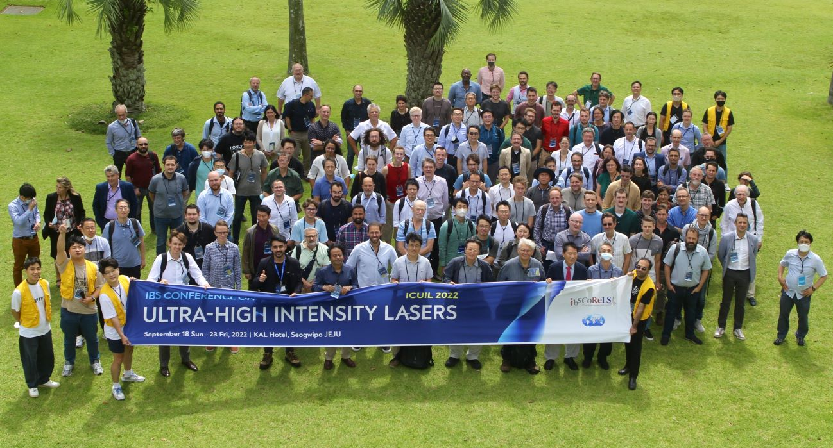
The key objectives for 2024 have been defined: organization of the next conference in Mexico (in order to continue expanding to countries where ICUIL-related research is emerging) and establishment of two new awards, one dedicated to Early Career Scientists and one to reward long-term scientific achievements of renowned established scientists.

